Resources from Community Ownership meeting

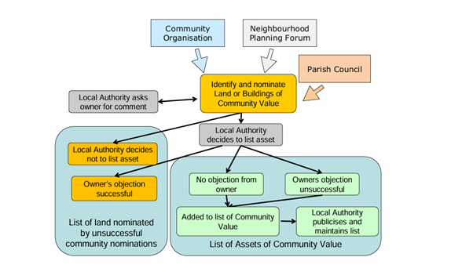
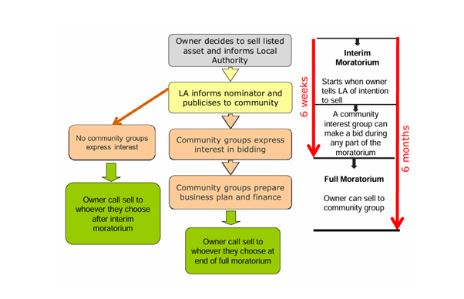
https://www.gov.uk/government/publications/community-ownership-fund-prospectus

https://www.gov.scot/publications/community-rights-to-buy-overview/

https://party.coop/campaign/support-community-right-to-buy

https://party.coop/unlockthehighstreet

https://www.uk.coop/support-your-co-op/community-shares/support/booster-fund

https://www.local.gov.uk/parliament/briefings-and-responses/prudential-code-capital-finance-local-authorities-lga

Cinema La Clef /Cinema Revival Foundation (Paris)
https://laclefrevival.org/en/home/

Cube Microplex / Microplex Holdings (Bristol)
https://cubecinema.com/pages/about/cube/

Cinema Nova/ Supernova Coop (Brussels)
https://www.nova-cinema.org/nova/

Star and Shadow Cinema (Newcastle)
https://starandshadow.org.uk/

https://www.theguardian.com/film/article/2024/jun/21/paris-arthouse-cinema-la-clef-to-reopen-after-buyout-from-squatters-collective

Curzon cinema chain sold for £3.9m. Curzon Mayfair threatened.
https://www.theguardian.com/film/2024/nov/12/curzon-cinemas-uk-sold

Hastings Commons – Taking Action For The Common Good

Ethex - make money do good

Overview - Resonance

